
Hormel Foods Corporation (Hormel)
Identity Management Foundation
Use Case Document Phase 2

Contents
Version Control 4
Revision History 4
Review History 4
Approval History 4
1 Introduction 5
1.1 Executive Summary 5
1.2 Scope of Implementation 6
1.3 Target State 7
1.4 Out of Scope 7
1.5 Intended Audience 8
1.6 Key Terminologies 8
2 Process Definitions 9
2.1 Approval and Provisioning 9
2.2 DMZ Active Directory Account Password Reset 9
2.3 User Manager Certification 10
2.4 Service Account Certification 10
2.5 Reconciliation 10
3 Functional Requirements 11
3.1 Approval and Provisioning 11
3.1.1 Process#1.1 - Approval Process 11
3.1.2 Process#1.2 - Provisioning – DMZ Maintenance Account Active Directory 14
3.1.3 Process#1.3 - Provisioning – DMZ Service and Generic Account Active Directory 15
3.1.4 Process#1.4 – Enable – DMZ Maintenance Active Directory Account 17
3.1.5 Process#1.5 – Deprovisioning – DMZ Active Directory 18
3.2 DMZ AD Account Password Reset 20
3.2.1 Process#2.1 – Maintenance Account Password Reset 20
3.2.2 Process#2.2 – Service and Generic Account Password Reset 21
3.3 User Manager Certification 22
3.3.1 Process#3.1 – User Manager Certification 22
3.4 Service and Generic Account Certification 24
3.4.1 Process#4.1 – Service and Generic Account Owner Certification Campaign 24
3.5 Reconciliation 26
3.5.1 Process#5.1.1 – Account and Access Reconciliation 26
3.5.2 Process#5.1.2 – Account and Access Reconciliation 27
4 Appendix 28
4.1 Appendix A: Oracle HCM to Saviynt Identity Attributes Mapping 28
4.2 Appendix B: Saviynt to DMZ Active Directory Mapping 29
4.2.1 User Status Mapping in DMZ Active Directory and Saviynt 29
4.3 Appendix C: Business Rules 30
4.4 Appendix D: Password Policy 30
4.5 Appendix E: Email Notification 31
4.6 Certification Campaign 32
4.6.1 User manager campaign 32
4.6.2 Service Account Owner campaign 33

Table of Tables
Table 1: Key Terminologies 8
Table 2: Approval and Provisioning 9
Table 3: DMZ Active Directory Account Password Reset 9
Table 4: Approval and Provisioning 10
Table 5: Approval and Provisioning 10
Table 6: Approval and Provisioning 10
Table 7: Approval Process DMZ Active Directory 12
Table 8: Approval Process DMZ Service/Generic Active Directory 13
Table 9: Provisioning – DMZ Active Directory 15
Table 10: Provisioning – DMZ Service and Generic Account Active Directory 16
Table 11: Enable – DMZ Maintenance Active Directory 17
Table 12: Deprovisioning – Active Directory 19
Table 13: Password Reset 20
Table 14: Service and Generic Password Reset 21
Table 15: User Manager Certification 22
Table 16: Service and Generic Account Owner Certification 24
Table 17: Account and Access Reconciliation – File Based Import 26
Table 18: Account and Access Reconciliation – Connected Application 27
Table 19: Oracle HCM to Saviynt SSM Identity Attributes Mapping 28
Table 20: Saviynt to DMZ Active Directory Mapping 29
Table 21: User Status Mapping in Active Directory 29
Table 22: Birth right Rules 30
Table 23: DMZ Active Directory Password Policy Service account 30
Table 23: DMZ Active Directory Password Policy Maintenance account 31
Table 24: Email Notification 31

Table of Figures
Figure 1: Scope of IAM Business Processes 6
Figure 2: Identity Management Future State 7
Figure 3: Approval Process for DMZ Maintenance Active Directory 11
Figure 4: Approval Process for DMZ Service/Generic account Active Directory 13
Figure 5: Provisioning – DMZ Maintenance Active Directory 14
Figure 6: Provisioning – DMZ Service and Generic Active Directory 15
Figure 7: Enable – DMZ Maintenance Active Directory 17
Figure 8: Deprovisioning – DMZ Active Directory 18
Figure 9: DMZ Active Directory - Maintenance Account Password Reset 20
Figure 10: DMZ Active Directory - Maintenance Account Password Reset 21

Version Control

Revision History
This section represents the change history of the document. All revisions of the document must be tracked by identifying a new version number, the date it was modified, the person making the change, and the reason for the change.
Version | Date | Author | Comments
0.1 | 09/07/2021 | Ajinkya Chavan | Initial Draft
0.2 | 04/10/2021 | Ajinkya Chavan | Incorporate KPMG team internal review comments.

Review History
Version | Reviewed By | Date
0.1 | Sai Mulam | 10/4/2021

Approval History
The signing of this document acknowledges everyone’s concurrence with the validity and accuracy of the information contained in this document.
Version | Approved By | Date

Introduction

Executive Summary
Hormel Foods Corporation (Hormel) has embarked upon a technology-driven transformation initiative for its Identity and Access Management (IAM) program. The key objective of this initiative is to implement Saviynt Identity Management platform as the strategic solution that will be used to automate enterprise access management across DMZ Active Directory target, User Manager and Service account certification campaign.
The purpose of this document is to define the IAM business processes that will be developed using Saviynt as part of this initiative. Follow up deliverables, including design document and technology implementation will refer to and support the specifics of processes defined in this document.
It is noted that currently Hormel use a combination of custom developed capabilities and manual tasks to enable these business processes. With the implementation of Saviynt, IAM processes are expected to become more formalized, standardized, automated and reduce the overall risk of un-authorized access within Hormel.
The scope of the user base that will be affected by this change is limited to Employees for current phase.

Scope of Implementation
Following diagram provides a brief overview of IAM processes and applications covered within the scope of this initiative:
Figure 1: Scope of IAM Business Processes
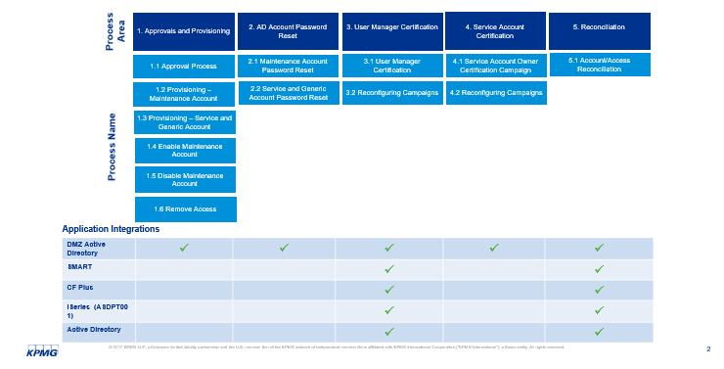

Target State
Figure 2: Identity Management Future State
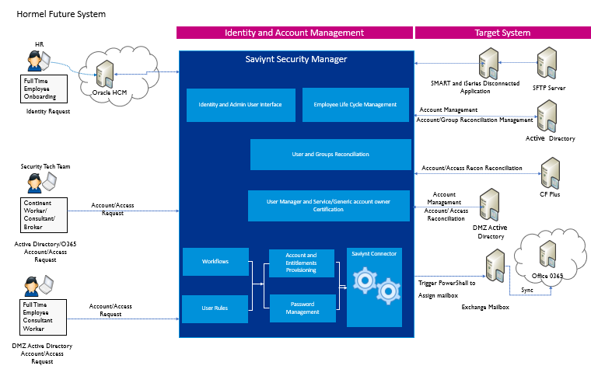
Figure 2 depicts the future state of the Identity Management processes to be achieved during this initiative. In future state,
- Saviynt Security Manager (SSM) will become the standards platform to manage identity and access of personnel and automate several manual processes. Employee data will be imported from HCM. SSM will import the HR data.
- As part of the initial (or Day 0) load, existing Employee and Contingent Workers account/entitlement data will be imported into the Identity Management System from DMZ Active Directory and future changes will be managed via SSM.
- Saviynt will connect SFTP server to fetch account and entitlement csv file from SFTP server to import disconnected application account and entitlement.
- For Full time employee and Contingent worker will raise the request for DMZ Active Directory.
- Saviynt will automate rest request / approval management for access in DMZ Active Directory.
- Certification will be configured to launch user manager and service/generic account campaign.

Out of Scope
- Any technology integration not specifically identified as Application Integration in Section 1.2 is not in scope.
- Password management for HFC Active Directory is not in scope of this phase.
- DMZ AD Service account entitlement/groups certification is out of scope.
- HFC Active Directory entitlement/groups certification will be out of scope.
- For disconnected application (SMART, iSeries) actual removeable of account in target system from Saviynt is out of scope.
- Birthright access for DMZ Active Directory account is out of scope.
- Only one iSeries (ASDPT001) application will be in scope.
- Pending worker will be not include into certification.
- Orphan and Inactive account will not in consider in certification campaign.

Intended Audience
- The primary audience for this document is the business owners of the proposed system. This document should be readable by these business owners, and they must be able to verify that their business requirements have been documented here completely, accurately, and unambiguously.
- Project team and stakeholders, whose role would be to review and confirm the scope and details of the business and non-functional requirements as captured by KPMG.
- Data Architects, Application Architects, and Technical Architects would also find the information in this document useful when they need to design a solution that will address these business requirements.

Key Terminologies
Table 1: Key Terminologies
Terminology | Definition
Employee | Full / Part-time Employees on Hormel’ payroll who are managed via the Hormel’s HR system.
Other Users | Contractor/Consultants or Contingent worker which are currently created in Active Directory directly then they are created in HCM.
Identity | Identity is a system of record that is uniquely associated with a user within an organization. Each user, full time, part-time, Contractor or Consultant within Hormel should have one and only one identity. In mature IAM programs, and identity is uniquely defined using a Username, which would stay with the user for life.
Account | An account is a system of record that is associated with various technologies users gain access to, for example, DMZ Active Directory etc. An IAM system would link identities to accounts across various integrated technologies. An identity may have none, one or more accounts based on the environment. If an account can’t be associated with an identity, it is considered an orphan account. Having such accounts adds the risk of unauthorized access to an organization.
Up-stream System | A up-stream system refers to the authoritative source of user records within an organization. At Hormel, Oracle HCM is considered the up-stream system for Employees.
Down-stream system | A downstream system refers to integration applications or technologies in which accounts are managed by IAM technologies. For the scope of this engagement, downstream systems collectively refer to DMZ Active Directory.

Process Definitions
This section describes the business requirements. The business requirements comprise of Joiner and Leaver process for Employees.

Approval and Provisioning
This process area covers the standardized access request and approval process for the systems integrated with Saviynt.
Table 2: Approval and Provisioning
P# | Name | Definition
1.1 | Approval Process – DMZ Active Directory, Generic, and Service Account. | The system shall provide a web interface for users (requesters) to submit requests for self, and appropriate approvers to approve requests for access to a new maintenance or Service account, on DMZ Active Directory.
1.2 | Provisioning – DMZ Active Directory Maintenance account. | The system shall have the ability to automatically create a maintenance account to an identity based on approved requests.
1.3 | Provisioning – DMZ Active Directory Generic and Service account. | The system shall have the ability to automatically create a Generic and Service account to an identity based on approved requests.
1.4 | Enable – DMZ Maintenance Account | The system shall have the ability to enable a maintenance account to an identity based on approved requests.
1.5 | Deprovisioning – DMZ Maintenance Account | The system shall have ability to disable/delete a maintenance account to an identity based on user termination in Oracle HCM or request based.

DMZ Active Directory Account Password Reset
This process area covers the processes associated with assisting users to reset their passwords for Maintenance, Generic, and Service accounts.
Table 3: DMZ Active Directory Account Password Reset
P# | Name | Definition
2.1 | Maintenance Account Password Reset | The solution shall provide a web interface to the users to reset their password by creating a temporary password.
2.2 | Service and Generic Account Password Reset | The solution shall provide a web interface to the users to reset their password by creating a temporary password.

User Manager Certification
This process area covers the reviews of individual user's access by their manager for integrated and disconnected applications. Based on the access review by the user’s manager, a user’s access will be revoked or continued.
Table 4: Approval and Provisioning
P# | Name | Definition
3.1 | User Manager Certification | The solution shall provide a web interface to the user’s manager to review the access of users and take a decision on whether to retain or revoke the access.
3.1 | Reconfiguration Campaign | Certification template shall provide to reconfigure campaign and launch certification.

Service Account Certification
This process area covers the reviews of individual Service and Generic account access by account owner (Primary certified) for DMZ Active Directory. Based on the access review by the owner, service or generic account access will be revoked or continued.
Table 5: Approval and Provisioning
P# | Name | Definition
4.1 | Service Account Owner Certification Campaign | The solution shall provide a web interface to the account owner to review the access to service or generic account and decide on whether to retain or revoke the access.
4.1 | Reconfiguration Campaign | Certification template shall provide to reconfigure campaign and launch certification.

Reconciliation
This process area covers the standardized account and access import into Saviynt.
Table 6: Approval and Provisioning
P# | Name | Definition
5.1 | Account/Access Reconciliation | The system shall provide a connection to target systems and import accounts and accesses into Saviynt.

Functional Requirements

Approval and Provisioning

Process#1.1 - Approval Process

Process#1.1.1 - Approval Process for DMZ Maintenance Active Directory
Figure 3: Approval Process for DMZ Maintenance Active Directory
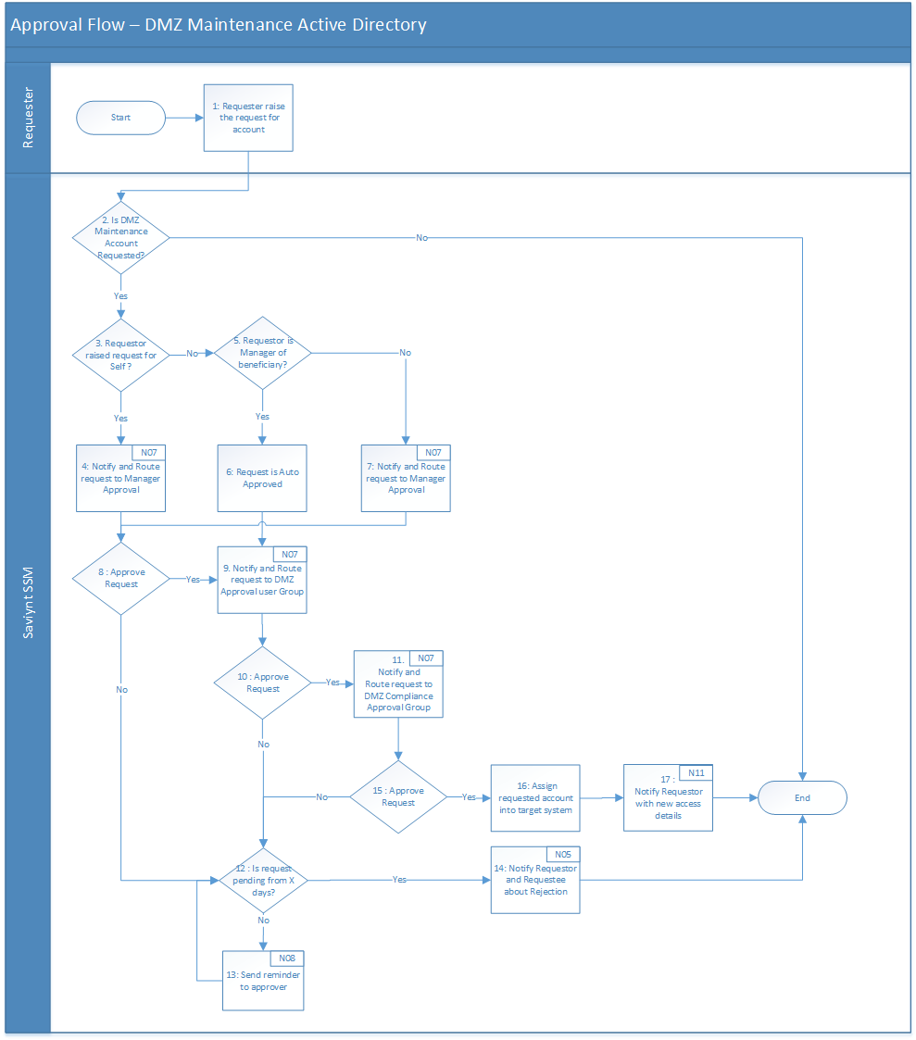
Table 7: Approval Process DMZ Active Directory
Process Description | The system shall provide a web interface to Beneficiary, Beneficiary’s Manager, End User to submit requests if department is “IT”, and appropriate approvers to approve requests for access to a new account on downstream systems.
Actors | - Saviynt.  - Requester (Beneficiary, Beneficiary’s Manager, Any other End User) with department as IT.  - Manager.  - DMZ Approval user group.  - DMZ Compliance user group.
Preconditions | - An Active Identity exists on Saviynt that was created as Employee via Oracle HCM.  - Identity doesn’t have the account which will be requested.
Triggers | - Requester submits an access request within the Saviynt.
Process Details | - Approval Process at Hormel is a serial workflow with one or more steps.  - Approvers are dependent upon who has made the request, and what has been requested.  - An approval process is consensus-based, i.e. request must be approved at every level. Any Denial will immediately end the workflow with no access grant.  - Refer to Appendix E for the Email notification template N05,N06,N07,N08, N11.
Exceptions | - Denial of request at any workflow stage would immediately end the workflow.  - Requests will be cancelled if no action has been taken at a stage in the workflow for 10 days.  - If Saviynt is unable to find an appropriate approver at any stage, e.g. User has no manager, it will be routed to IAM Admin.
Post Condition | - An account is assigned to the Requestee in the IAM system. IAM system provisions new accounts based on the request.
Assumptions | - No downstream changes will be made to the user’s access and IAM Admin is expected to reach out to the user and assist them to gain access to needed systems.

Process#1.1.2 - Approval Process for DMZ Service/Generic account Active Directory
Figure 4: Approval Process for DMZ Service/Generic account Active Directory
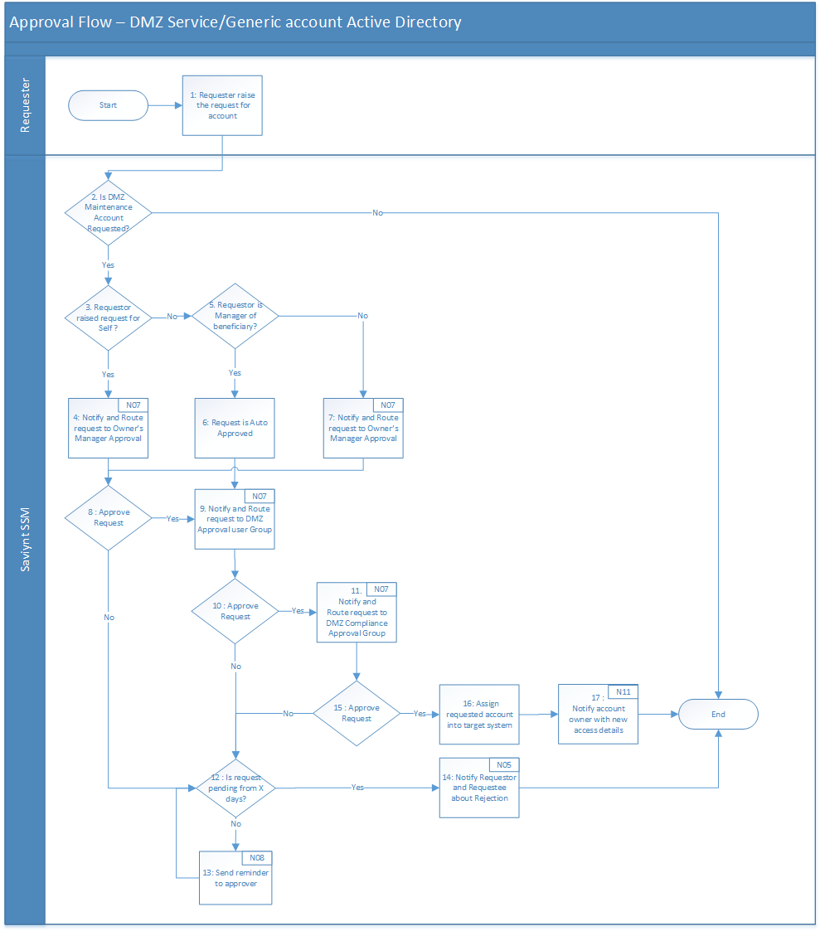
Table 8: Approval Process DMZ Service/Generic Active Directory
Process Description | The system shall provide a web interface to Beneficiary, Beneficiary’s Manager, End User to submit requests if department is “IT”, and appropriate approvers to approve requests for access to a new Service/Generic account on downstream systems.
Actors | - Saviynt.  - Requester (Beneficiary, Beneficiary’s Manager, Any other End User) with department as IT.  - Owner’s Manager.  - DMZ Approval user group.  - DMZ Compliance user group.
Preconditions | - An Active Identity exists on Saviynt that was created as Employee via Oracle HCM.  - Identity doesn’t have the account which will be requested.
Triggers | - Requester submits an access request within the Saviynt.
Process Details | - Approval Process at Hormel is a serial workflow with one or more steps.  - Approvers are dependent upon who has made the request, and what has been requested.  - An approval process is consensus-based, i.e. request must be approved at every level. Any denial will immediately end the workflow with no access grant.  - Refer to Appendix E for the Email notification template N05,N06,N07,N08, N11.
Exceptions | - Denial of request at any workflow stage would immediately end the workflow.  - Requests will be cancelled if no action has been taken at a stage in the workflow for 10 days.  - If Saviynt is unable to find an appropriate approver at any stage, e.g. User has no manager, it will be routed to IAM Admin.
Post Condition | - An account is assigned to the requestee in the IAM system. IAM system provisions new accounts based on the request.
Assumptions | - No downstream changes will be made to the user’s access and IAM Admin is expected to reach out to the user and assist them to gain access to needed systems.

Process#1.2 - Provisioning – DMZ Maintenance Account Active Directory
Figure 5: Provisioning – DMZ Maintenance Active Directory
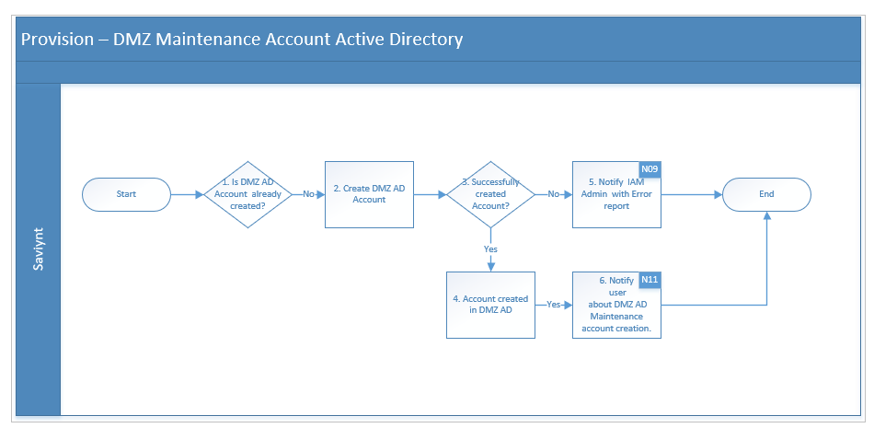
Table 9: Provisioning – DMZ Active Directory
Process Description | The system shall have the ability to automatically create to an account based on approved requests.
Actors | - Saviynt
Preconditions | - Request for access for the user has been approved.
Triggers | - Requester submits an access request within the Saviynt.
Process Details | This section provides additional details about the process flow defined above. Each number corresponds to equivalent step on the flow diagram. Additional details may include appropriate references for evaluation logic, transformation mappings.  - Is the DMZ Maintenance AD Account already created?  - An Active AD Account must be linked to the identity on Saviynt.  - Create DMZ Maintenance AD Account.  - DMZ Maintenance AD account will be created, and attribute mapping should be done based on Appendix B.  - Account will be created into HRLDMZ-Users-MaintenanceAccount OU.  - Successfully created Account ?  - DMZ AD Command returns success.  - DMZ AD account will be provisioned to user in Saviynt  - Notify IAM Admin with error if operation fails.  - If any error occurs while creating AD account, an email notification will be sent to the IAM Administrator mailbox.  - Refer to Appendix E for the Email notification template N07.  - Notify user about AD account creation.  - Email notification will be sent to user with DMZ AD user name and first-time password.
Post Condition | - An DMZ AD account will be created in Saviynt and in AD target system.
Exceptions | - If all the required attribute is not present for AD account creation then provisioning will fail.
Assumptions | NA

Process#1.3 - Provisioning – DMZ Service and Generic Account Active Directory
Figure 6: Provisioning – DMZ Service and Generic Active Directory
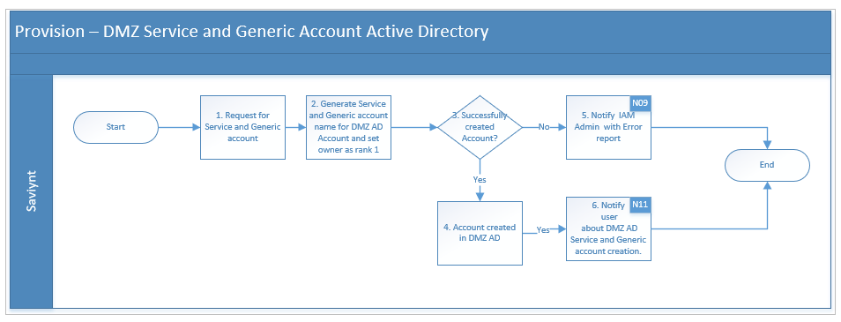
Table 10: Provisioning – DMZ Service and Generic Account Active Directory
Process Description | The system shall have the ability to automatically create to an account based on approved requests.
Actors | - Saviynt  - Service account owner
Preconditions | - Request for access for the user has been approved.
Triggers | - Requester submits an access request within the Saviynt.
Process Details | This section provides additional details about the process flow defined above. Each number corresponds to equivalent step on the flow diagram. Additional details may include appropriate references for evaluation logic, transformation mappings.  - User request service and generic account for DMZ Active Directory.  - Generate service and generic account name on select account type and set account towner as rank 1.  - Create Service and Generic account in DMZ .  - Service and Generic DMZ AD account will be created, and attribute mapping should be done based on Appendix B.  - Account will be created into HRLDMZ-Users-ServiceAccounts and HRLDMZ-Users-GenericAccounts OU.  - Successfully created Account ?  - DMZ AD Command returns success.  - DMZ AD account will be provisioned to user in Saviynt  - Notify IAM Admin with error if operation fails.  - If any error occurs while creating DMZ AD account, an email notification will be sent to the IAM Administrator mailbox.  - Refer to Appendix E for the Email notification template N07.  - Notify user about AD account creation.  - Email notification will be sent to user with DMZ AD user name and first-time password.
Post Condition | - An DMZ AD account will be created in Saviynt and in AD target system.
Exceptions | - If all the required attribute is not present for AD account creation then provisioning will fail.
Assumptions | NA

Process#1.4 – Enable – DMZ Maintenance Active Directory Account
Figure 7: Enable – DMZ Maintenance Active Directory
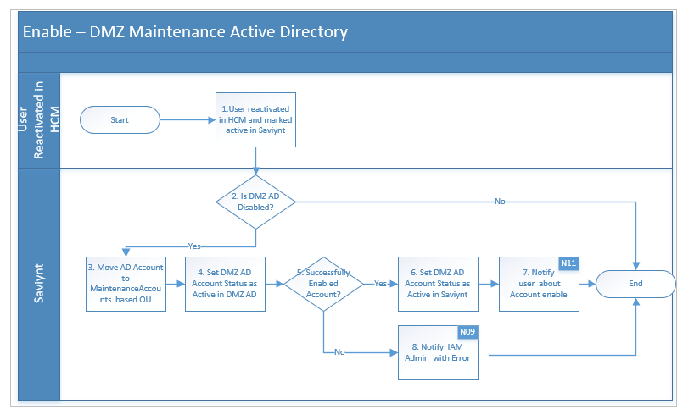
Table 11: Enable – DMZ Maintenance Active Directory
Process Description | The solution shall have the ability to automatically connect to the up-stream HR system, identify users whose profile got activated, and enabled associated DMZ Active Directory accounts in connected downstream systems.
Actors | HR, Saviynt
Preconditions | - HR Administrator has re-hired an existing Employee record on Oracle HCM.  - Saviynt triggers the user import job to fetch all the Active and Inactive Employee records from Oracle HCM.
Triggers | - HR Administrator has updated an Employee record on Oracle HCM in fields that are significant for Saviynt.  - Identity is updated on the Saviynt via the Authoritative source reconciliation process.  - Employee status changes to ‘Active’ in Saviynt.
Process Details | - User reactivated in HCM and marked active in Saviynt.  - HR Administrator update the user’s status to active.  - The existing inactive user’s identity gets enabled on Saviynt.  - Refer to Appendix A for HCM to Saviynt Profile Attributes Mapping.  - Is DMZ AD Disabled?  - Saviynt Identity must have at least 1 DMZ Active Directory account linked to it in Disabled status.  - Move DMZ AD Account to MaintenaceAccounts based OU in DMZ AD.  - Set Active Directory Account Status to Enabled  - Refer to Appendix B for corresponding “Enable” status on AD.  - Notify User about Enable Account.  - Refer to Appendix E for the Email notification template N11.  - Notify IAM Admin with error if operation fails.  - Send an email notification to the IAM Administrator mailbox.
Post Condition | - Saviynt must activate the identity and enable DMZ Active Directory account in target applications.
Exceptions | - Downstream provisioning may fail due to data discrepancy or network issues. In such a case, send an email to the IAM Support mailbox using template N09.
Assumptions | - HR System has Employee, Pending Worker records and Contingent Worker data. Saviynt should be able to pull all records.  - There are no duplicate entries in the HR System for any given Employee.  - Critical attributes that indicate the action that is required for the given record (i.e. create, update, enable and disable) are correctly updated in the HR System.  - Connection to DMZ Active Directory is always available.  - Saviynt will move the DMZ AD account to MaintenanceAccounts based OU only.

Process#1.5 – Deprovisioning – DMZ Active Directory
Figure 8: Deprovisioning – DMZ Active Directory
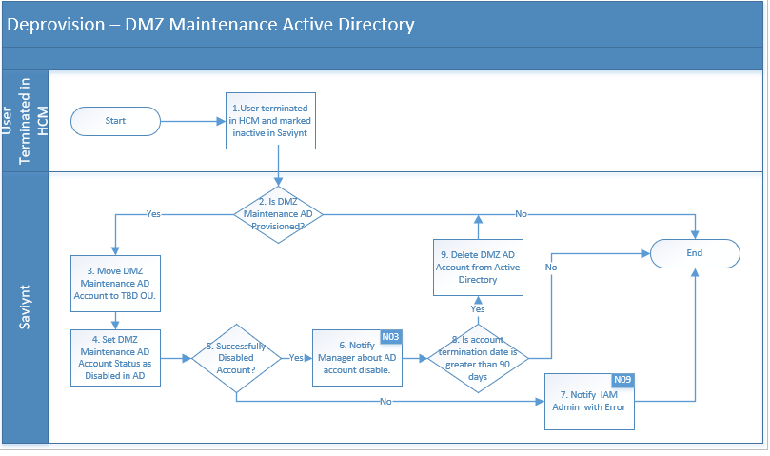
Table 12: Deprovisioning – Active Directory
Process Description | The solution shall have the ability to automatically connect to the up-stream HR system, identify users whose profile got inactivated, and disable associated DMZ Maintenance Active Directory accounts in connected downstream systems.
Actors | HR, Saviynt
Preconditions | - HR Administrator has terminated an Employee record on Oracle HCM.  - User’s termination date has been notified to HR  - HR must update the employee end date and status in an authoritative source.  - HR changes the user’s status to ‘’Terminated” and set the termination date  - IAM system synchronizes with an Authoritative source to find the user as terminated
Triggers | - HR Administrator has updated an Employee record on Oracle HCM in fields that are significant for Saviynt.  - Identity is updated on the Saviynt via the Authoritative source reconciliation process.  - Employee status changes to ‘Inactive’ in Saviynt.
Process Details | - User terminated in HCM and marked inactive in Saviynt.  - HR Administrator update the users End date and status to terminate.  - The existing active user’s identity gets disabled on Saviynt.  - Refer to Appendix A for HCM to Saviynt Profile Attributes Mapping.  - Is DMZ Maintenance AD Provisioned?  - Saviynt Identity must have at least 1 DMZ Active Directory account linked to it.  - Move DMZ Maintenance AD Account to TBD OU from AD.  - Move DMZ Maintenance AD account to TBD OU.  - Set Maintenance Active Directory Account Status to Disabled  - Refer to Appendix B for corresponding “Disable” status on Maintenance AD.  - Notify Manager about Terminated User  - Refer to Appendix A to identify the user’s Manager on Saviynt SSM.  - Refer to Appendix E for the Email notification template N03.  - Refer to Appendix E for the Email notification template N09.  - Is account termination date being greater than 90 days and mail attribute is empty in AD  - DMZ Maintenance Active Directory account will be deleted after 90 days once it’s disabled.  - If termination date is less than 90 days then account stays in TBD OU in Disable state.  - Notify IAM Admin with error if operation fails.  - Send an email notification to the IAM Administrator mailbox.
Post Condition | - IAM system must disable the identity and disable Active Directory account in target applications.
Exceptions | - Downstream provisioning may fail due to data discrepancy or network issues. In such a case, send an email to the IAM Support mailbox using template N07.
Assumptions | - HR System has Employee, Pending Worker records and Contingent Worker data. Saviynt should be able to pull all records.  - There are no duplicate entries in the HR System for any given Employee.  - Critical attributes that indicate the action that is required for the given record (i.e. create, update, enable and disable) are correctly updated in the HR System.  - Connection to Active Directory is always available.

DMZ AD Account Password Reset

Process#2.1 – Maintenance Account Password Reset
Figure 9: DMZ Active Directory - Maintenance Account Password Reset
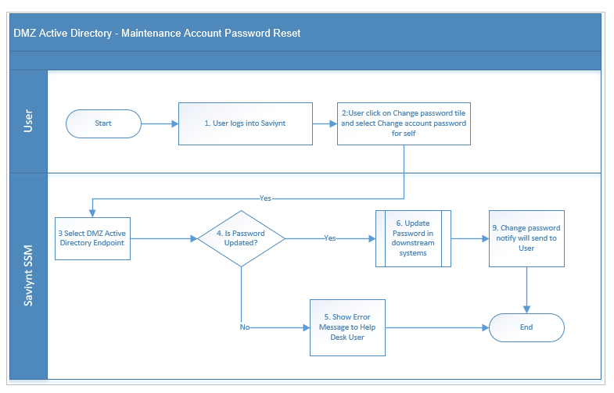
Table 13: Password Reset
Process Description | The solution shall provide a web interface to end user to reset a user’s password by creating a temporary password.
Actors | - User  - Saviynt SSM
Preconditions | - Identity is present in Saviynt  - Users must have access to Saviynt.
Trigger | - When the user forgot DMZ maintenance account password.
Process Details | The following bullet points correspond to the process flow described above. Additional information is provided as bullet points.  - User accesses Saviynt web console, logs into Saviynt using SSO, and accesses the Change password tile and select change account password for self.  - User prompted to enter a new password and confirm the password.  - Is Password Updated in Saviynt, continue to Step 4  - Update Password in downstream systems.  - Notify password to End User. Process End  - If the password change is unsuccessful, Show error message. Process End.
Post Condition | - Password will be changed in the downstream system.
Exceptions | - Password sync may fail due to connection issues in target systems.
Assumptions | - Identity already exists in Saviynt.  - DMZ AD are properly connected with Saviynt.

Process#2.2 – Service and Generic Account Password Reset
Figure 10: DMZ Active Directory - Maintenance Account Password Reset
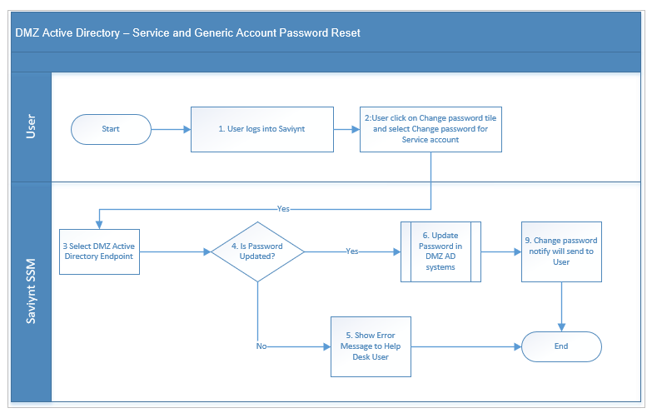
Table 14: Service and Generic Password Reset
Process Description | The solution shall provide a web interface to end user to reset a user’s password by creating a temporary password.
Actors | - User  - Saviynt SSM
Preconditions | - Identity is present in Saviynt  - Users must have access to Saviynt.
Trigger | - When the user forgot DMZ service and generic account password.
Process Details | The following bullet points correspond to the process flow described above. Additional information is provided as bullet points.  - User accesses Saviynt web console, logs into Saviynt using SSO, and accesses the Change password tile and select change password for service account.  - User prompted to enter a new password and confirm the password.  - Is Password Updated in Saviynt, continue to Step 4  - Update Password in downstream systems.  - Notify password to End User. Process End  - If the password change is unsuccessful, Show error message. Process End.
Post Condition | - Password will be changed in the DMZ Active Directory system.
Exceptions | - Password sync may fail due to connection issues in target systems.
Assumptions | - Identity already exists in Saviynt.  - DMZ AD are properly connected with Saviynt.

User Manager Certification

Process#3.1 – User Manager Certification
Figure 32: User Manager Certification
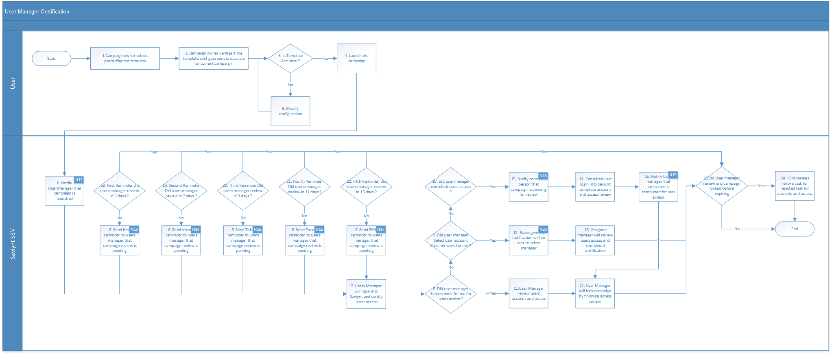

Table 15: User Manager Certification
Process Description | The solution shall provide a web interface to the user’s manager to review access of connected and disconnected target system
Actors | - Campaign Owner  - Saviynt SSM  - User Manager Certifier
Preconditions | - User with Campaign owner access is required to launch campaign
Trigger | - Campaign owner launches campaign periodically.
Success Scenario | - Campaign owner clicks on create campaign and selects the pre-configured template for target system  - Campaign owner verifies that the configuration is accurate as per current campaign requirement  - Decision is taken whether to modify the configuration or not  - Once configuration is verified, the certification is launched  - Changes are made if required on configuration and campaign will be launched  - Notifications will be sent out to all user managers that campaign has started  - Saviynt sends out notifications (N12) addressing user manager with campaign name that it is pending in their queue to take action. Refer to Appendix K for notification details.  - User Manager will login to review account and entitlements  - User manager must certify that account is owned by them by clicking “belongs to me” before they can certify accounts and entitlement  - If user manager select account/Entitlement does not belong to me then, original certifier need to select different manager as a certifier. Notification will be sent to assigned manager to that certification is pending. Then reassigned manager must need to review and certify access by clicking belong to me and complete access review .  - If users manager has consulted that account or entitlement needs to be certified by another user, notification will be sent to that user. Refer to Appendix K for notification details.  - Consulted user receives a notification from Saviynt to take action  - Consulted user logs into Saviynt and finishes the review  - Saviynt sends a notification to original certifier that consulted user has completed his review. Refer to Appendix K for notification details.  - If user manager consulted a user to certify certain account, notification will be sent out to consulted user that a campaign is pending their queue. Refer to Appendix K for notification details.  - User manager campaign will lock the campaign by clicking on finish review and providing comments  - Saviynt checks if the campaign is completed and locked before expiring.  - Saviynt creates revoke tasks for all rejections in review from user manager campaign.  - For the certifiers who hasn’t completed their review, there will be periodic reminders sent from Saviynt started with Day 3 as first reminder.  - Second reminder will be sent on day 7 for user’s manager that hasn’t taken any action on campaign. Refer to Appendix K for notification details  - Third reminder will be sent on day 9 for user’s manager that hasn’t taken any action on campaign. Refer to Appendix K for notification details  - Fourth reminder will be sent on day 11 for user’s manager that hasn’t taken any action on campaign. Refer to Appendix K for notification details  - Fifth reminder will be sent on day 15 for user’s manager that hasn’t taken any action on campaign. Refer to Appendix K for notification details  - Every time user’s manager completes their campaign it goes back to check on step 13.
Post Condition | - If a user’s manager has not completed his campaign within 90 days, accounts will retain access  - If a user’s manager has rejected an access for accounts, such accounts will lose access post campaign.  - If a user’s manager has approved an access, such accounts will retain their access.
Exceptions | - Any accounts that are not correlated to users will not be in scope for certification
Assumptions | - Pending worker will be not part of certification.  - Only active account will be consider in certification.

Service and Generic Account Certification

Process#4.1 – Service and Generic Account Owner Certification Campaign
Figure 32: Service and Generic Account Owner Certification
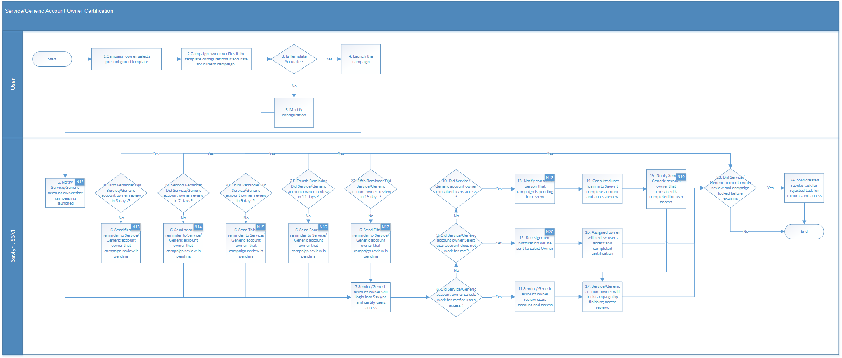
Table 16: Service and Generic Account Owner Certification
Process Description | The solution shall provide a web interface to the user’s manager to review access of connected and disconnected target system
Actors | - Campaign Owner  - Saviynt SSM  - Service and Generic Account Owner
Preconditions | - User with Campaign owner access is required to launch campaign
Trigger | - Campaign owner launches campaign periodically.
Success Scenario | - Campaign owner clicks on create campaign and selects the pre-configured template for target system  - Campaign owner verifies that the configuration is accurate as per current campaign requirement  - Decision is taken whether to modify the configuration or not  - Once configuration is verified, the certification is launched  - Changes are made if required on configuration and campaign will be launched  - Notifications will be sent out to all Service and Generic Account Owner that campaign has started  - Saviynt sends out notifications addressing Service and Generic Account Owner with campaign name that it is pending in their queue to take action. Refer to Appendix K for notification details.  - Service and Generic Account Owner will login to review account and entitlements  - Service and Generic Account Owner must certify that account is owned by them by clicking “belongs to me” before they can certify accounts and entitlement  - If Service and Generic Account Owner select account/Entitlement does not belong to me then, original certifier need to select different owner as a certifier. Notification will be sent to assigned Service and Generic Account Owner to that certification is pending. Then reassigned of owner must need to review and certify access by clicking belong to me and complete access review .  - If Service and Generic Account Owner has consulted that account or entitlement needs to be certified by another owner, notification will be sent to that owner. Refer to Appendix K for notification details.  - Consulted user receives a notification from Saviynt to take action  - Consulted user logs into Saviynt and finishes the review  - Saviynt sends a notification to original certifier that consulted user has completed his review. Refer to Appendix K for notification details.  - If Service and Generic Account Owner consulted a user to certify certain account, notification will be sent out to consulted user that a campaign is pending their queue. Refer to Appendix K for notification details.  - Service and Generic Account Owner campaign will lock the campaign by clicking on finish review and providing comments  - Saviynt checks if the campaign is completed and locked before expiring.  - Saviynt creates revoke tasks for all rejections in review from Service and Generic Account Owner campaign.  - For the certifiers who hasn’t completed their review, there will be periodic reminders sent from Saviynt started with Day 3 as first reminder.  - Second reminder will be sent on day 7 for Service and Generic Account Owner that hasn’t taken any action on campaign. Refer to Appendix K for notification details  - Third reminder will be sent on day 9 for Service and Generic Account Owner that hasn’t taken any action on campaign. Refer to Appendix K for notification details  - Fourth reminder will be sent on day 11 for Service and Generic Account Owner that hasn’t taken any action on campaign. Refer to Appendix K for notification details  - Fifth reminder will be sent on day 15 for Service and Generic Account Owner that hasn’t taken any action on campaign. Refer to Appendix K for notification details  - Every time Service and Generic Account Owner completes their campaign it goes back to check on step 13.
Post Condition | - If a Service and Generic Account Owner has not completed his campaign within 60 days, accounts will retain access  - If a Service and Generic Account Owner has rejected an access for accounts, such accounts will lose access post campaign.  - If a Service and Generic Account Owner has approved an access, such accounts will retain their access.
Assumptions | - Pending worker will be not part of certification.  - Only active service and generic account will be consider in certification.

Reconciliation

Process#5.1.1 – Account and Access Reconciliation
Figure 32: Account and Access Reconciliation – File Based Import
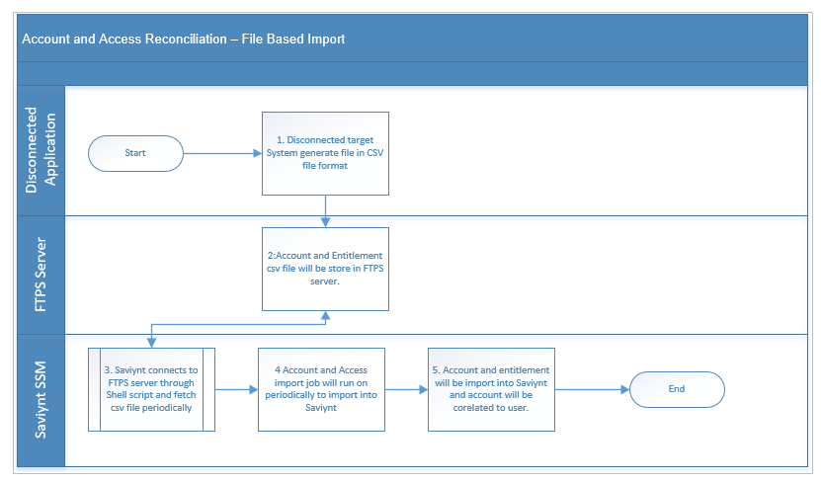
Table 17: Account and Access Reconciliation – File Based Import
Process Description | The solution shall provide to the fetch account and entitlement csv file from disconnected target system and import account and entitlement into Saviynt
Actors | - Disconnected Application.  - Saviynt SSM  - SFTP server
Preconditions | - Target system must able to generate csv file in SFTP server.  - Saviynt should able to connect to SFTP server.  - Shell script should be placed into Saviynt to fetch file from SFTP server into Saviynt.
Trigger | - Saviynt Shell script connect to SFTP server and fetch account and entitlement csv file on Saviynt server.
Success Scenario | - Target system generate account and entitlement file in csv file format.  - Once account and entitlement file is placed on SFTP server.  - Saviynt Shell script connects to SFTP server to download csv file on Saviynt server.  - Once file is available on Saviynt server, account and entitlement import job runs on schedule based in Saviynt.
Post Condition | - Account and entitlement will be import into Saviynt and correlated to user.
Assumptions | - SFTP server will be available to fetch file from Saviynt.  - Account and entitlement files are generated into CSV file format.

Process#5.1.2 – Account and Access Reconciliation
Figure 32: Account and Access Reconciliation – Connected Application
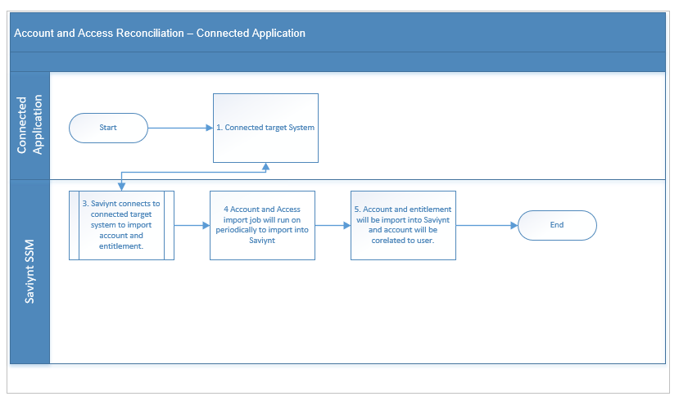
Table 18: Account and Access Reconciliation – Connected Application
Process Description | The solution shall provide to the fetch account and entitlement csv file from connected target system and import an account and entitlement into Saviynt
Actors | - Connected Application.  - Saviynt SSM
Preconditions | - Saviynt connector must be able communicate to connected target application.  - Import account and entitlement job must be configured.
Trigger | - Saviynt connects to connected target application to import account and entitlement into Saviynt.
Success Scenario | - Saviynt connects to target application to import account and entitlement into Saviynt.
Post Condition | - Account and entitlement will be import into Saviynt and correlated to user.
Assumptions | - Saviynt is able to connect to target system.

Appendix

Appendix A: Oracle HCM to Saviynt Identity Attributes Mapping
Oracle HCM system is the authoritative source of identities for employees in the enterprise. Consolidated user information is retrieved by using emps and Worker API. This consolidated view is used to pull employees’ identity attributes into Saviynt.

Table 19: Oracle HCM to Saviynt SSM Identity Attributes Mapping
HCM Attribute | Saviynt Attribute | Required/Optional
FirstName | firstName | Required
MiddleName | middleName | Optional
LastName | lastName | Required
DisplayName | displayName | Optional
PreferredName | preferedFirstName | Optional
PersonNumber | employeeId | Required
HireDate | startDate | Required
TerminationDate | enddate | Optional
WorkerType | employeeType | Required
JobCode | jobcode | Required
Name | title | Required
LocationCode | locationnumber | Required
DepartmentName | departmentname | Required
LegalEmployerName | companyname | Required
AssignmentStatusType | statuskey | Required
Hire Date/Projected Start Date | startDate | Required
LocationName | locationdesc | Required
Address1 | street | Required
TownOrCity | city | Required
Region2 | state | Required
Country | country | Required
AssignmentCategory | employeeclass | Required
PostalCode | customproperty1 | Required
PersonID | customproperty6 | Required
ManagerAssignmentId | customproperty7 | Required
AssignmentId | customproperty8 | Required
LocationId | customproperty9 | Required
JobId | customproperty10 | Required
WorkAtHomeFlag | customproperty11 | Optional
ActionCode | customproperty12 | Required
assignmentsDFF.payRule | customproperty16 | Required

The identity state changes during the employee’s lifecycle in the organization. State changes are used by Saviynt to trigger various lifecycle events, which perform access to provisioning and de-provisioning. State changes are triggered by a trusted source aggregation or by external events like Suspension/Termination by managers. Provisioning/De-provisioning to target applications is carried out by the Identity Access Rules defined in Saviynt. We primarily use technical rules and User update rules, which are part of Identity access rules, to handle identity state change.

Appendix B: Saviynt to DMZ Active Directory Mapping
DMZ Active Directory will be treated as an end target application that is requested by end-users via Saviynt UI. The below table shows the attribute mapping between Saviynt and DMZ Active Directory.
Table 20: Saviynt to DMZ Active Directory Mapping
Saviynt Attribute Name | DMZ Active Directory Attribute Name | Required for Create | Required for Update | Note
UserName | sAMAccountName | Yes | No
employeeId | employeeNumber | Yes | No
Accountname | givenName | Yes | No
accountname@domain | userPrincipalName | Yes | No
statuskey | userAccountControl | Yes | No
 | accountExpires | Yes | No | Will only set on delete /disable
accountname | displayname | Yes | No
 | pwdLastSet | Yes | No | 0
description | description | Yes | No
 | cn/dn | Yes | No

User Status Mapping in DMZ Active Directory and Saviynt
The following section provides details about user status mapping in Active Directory and Saviynt.
Table 21: User Status Mapping in Active Directory
Operation | User Account Control Description | User Account Control Value in Active Directory (AD) | Status in Saviynt
Enable | NORMAL_ACCOUNT, Password Required | 512 | Active
Disable | Disabled Account, Password Required | 514 | Inactive
Enable | Enabled, Password Not Required | 544 | Active
Disable | Disabled, Password Not Required | 546 | Inactive
Enable | Enabled, Password Never Expire | 66048 | Active
Disabled | Password Never Expire | 66050 | Inactive
Disabled | Disabled, Password Never Expire & Not Required | 66082 | Inactive

Appendix C: Business Rules
This section lists and describes the business rules applicable to the proposed system.
Table 22: Birth right Rules
Business Rule Id | Rule Name | Rule Description
BR001 | DMZ Active Directory Recon Rule | EmployeeID in Saviynt = EmployeeNumber in DMZ Active Directory

Appendix D: Password Policy
The following section provides details about the DMZ Active Directory Password Policy.
Table 23: DMZ Active Directory Password Policy Service account
Policy Name | Hormel Active Directory Password Policy
Policy Description | This is Active Directory password policy for Hormel users.
Policy Scope | USER/DMZ Active Directory account
Maximum password age | 90 days
Minimum password age | 1 days
Minimum Digit Characters | 1
Minimum Special Character | 1
Minimum Uppercase Characters | 1
Minimum Length | 14
Last Password History | 24

Table 24: DMZ Active Directory Password Policy Maintenance account
Policy Name | Hormel Active Directory Password Policy
Policy Description | This is Active Directory password policy for Hormel users.
Policy Scope | USER/DMZ Active Directory account
Maximum password age | 90 days
Minimum password age | 1 days
Minimum Digit Characters | 1
Minimum Special Character | 1
Minimum Uppercase Characters | 1
Minimum Length | 15
Last Password History | 24

Appendix E: Email Notification
The following section provides basic details about the type of email notification and recipients. Email Templates, including additional details of users that need to be sent will be finalized during design and implementation.
Table 25: Email Notification
No | Notification Name | From | To
N01 | Send the notification to the Manager with Account details. | <Get it from Hormel> | Manager
N02 | Send the notification to the Manager with Rehired Account details. | <Get it from Hormel> | Manager
N03 | Send the notification to the Manager about user terminated | <Get it from Hormel> | Manager
N05 | Notify the requester and requestee about the rejected request. | <Get it from Hormel> | Requester
N06 | Notify the requester and requestee about the new access details requests. | <Get it from Hormel> | Requester
N07 | Notify the approver about the new request assigned for approval | <Get it from Hormel> | Approver
N08 | Send reminder notification to approver on 3rd day | <Get it from Hormel> | Approver
N09 | Notify IAM Administrators about various errors in the system (e.g. provisioning failure, use disablement failure or any other abnormal system error) | <Get it from Hormel> | IAM Administrator
N10 | Notify the requester about the access request expiry on 10th day if no action has been taken on request till that time. | <Get it from Hormel> | Requester
N11 | Send the notification to the user with Account details. | <Get it from Hormel> | user
N12 | Notify certifier that campaign is launched and is waiting their action | <Get it from Hormel> | Certifier
N13 | First Reminder that certifier has not taken action on campaign assigned to them | <Get it from Hormel> | Certifier
N14 | Second Reminder that certifier has not taken action on campaign assigned to them | <Get it from Hormel> | Certifier
N15 | Third Reminder that certifier has not taken action on campaign assigned to them | <Get it from Hormel> | Certifier
N16 | Fourth Reminder that certifier has not taken action on campaign assigned to them | <Get it from Hormel> | Certifier
N17 | Fifth Reminder that certifier has not taken action on campaign assigned to them | <Get it from Hormel> | Certifier
N18 | Notify consulted user that campaign is pending their action | <Get it from Hormel> | Consulted User, Certifier
N19 | Notify Certifier that consulted user has taken action on certification | <Get it from Hormel> | Certifier
N20 | Notify Certifier that reassignment user has taken action on certification | <Get it from Hormel> | Certifier

Certification Campaign

User manager campaign
Following attached sheet define that user manager campaign will be configured.

Service Account Owner campaign
Following attached sheet define that user manager campaign will be configured.

